# VPC PEERING (by TERRAFORM Script)

Creating one ec2 instance manually

Connecting to the instance

apt install unzip

curl "https://awscli.amazonaws.com/awscli-exe-linux-x86_64.zip" -o "awscliv2.zip"

unzip awscliv2.zip

sudo ./aws/install

aws configure 🡪 give the details mentioned below frm the IAM🡪 user

access key

secret access key

region –us-east-2

formate –table

mkdir terraform

cd terraform

vi terraformblock.tf

terraform {

required_providers {

aws = {

source = "hashicorp/aws"

version = "5.66.0"

}

}

}

Vi provider.tf

Provider “aws” {

Profile = “default’

Region = “ us-east-2”

}

VPC PEERING SCRIPT (Peering.tf)

# Create VPC 1

resource "aws_vpc" "vpc1" {

cidr_block = "10.0.0.0/16"

tags = {

Name = "VPC1"

}

}

# Create Subnet for VPC 1

resource "aws_subnet" "subnet1" {

vpc_id = aws_vpc.vpc1.id

cidr_block = "10.0.1.0/24"

availability_zone = "us-east-2a"

map_public_ip_on_launch = true

tags = {

Name = "Subnet1"

}

}

# Create Internet Gateway for VPC 1

resource "aws_internet_gateway" "igw1" {

vpc_id = aws_vpc.vpc1.id

tags = {

Name = "IGW1"

}

}

# Create Route Table for VPC 1 and associate with the subnet

resource "aws_route_table" "rt1" {

vpc_id = aws_vpc.vpc1.id

route {

cidr_block = "0.0.0.0/0"

gateway_id = aws_internet_gateway.igw1.id

}

}

resource "aws_route_table_association" "rta1" {

subnet_id = aws_subnet.subnet1.id

route_table_id = aws_route_table.rt1.id

}

# Create Security Group for VPC 1

resource "aws_security_group" "sg1" {

name = "vpc1-sg"

vpc_id = aws_vpc.vpc1.id

ingress {

from_port = 22

to_port = 22

protocol = "tcp"

cidr_blocks = ["0.0.0.0/0"]

}

egress {

from_port = 0

to_port = 0

protocol = "-1"

cidr_blocks = ["0.0.0.0/0"]

}

}

# Create EC2 Instance in VPC 1

resource "aws_instance" "instance1" {

ami = "ami-085f9c64a9b75eed5" # Replace with a valid AMI ID

instance_type = "t2.micro"

subnet_id = aws_subnet.subnet1.id

key_name = "ohio" # Replace with your AWS key pair name

vpc_security_group_ids = [aws_security_group.sg1.id]

associate_public_ip_address = true

tags = {

Name = "Instance1"

}

}

# Create VPC 2

resource "aws_vpc" "vpc2" {

cidr_block = "10.1.0.0/16"

tags = {

Name = "VPC2"

}

}

# Create Subnet for VPC 2

resource "aws_subnet" "subnet2" {

vpc_id = aws_vpc.vpc2.id

cidr_block = "10.1.1.0/24"

availability_zone = "us-east-2b"

map_public_ip_on_launch = true

tags = {

Name = "Subnet2"

}

}

# Create Internet Gateway for VPC 2

resource "aws_internet_gateway" "igw2" {

vpc_id = aws_vpc.vpc2.id

tags = {

Name = "IGW2"

}

}

# Create Route Table for VPC 2 and associate with the subnet

resource "aws_route_table" "rt2" {

vpc_id = aws_vpc.vpc2.id

route {

cidr_block = "0.0.0.0/0"

gateway_id = aws_internet_gateway.igw2.id

}

}

resource "aws_route_table_association" "rta2" {

subnet_id = aws_subnet.subnet2.id

route_table_id = aws_route_table.rt2.id

}

# Create Security Group for VPC 2

resource "aws_security_group" "sg2" {

name = "vpc2-sg"

vpc_id = aws_vpc.vpc2.id

ingress {

from_port = 22

to_port = 22

protocol = "tcp"

cidr_blocks = ["0.0.0.0/0"]

}

egress {

from_port = 0

to_port = 0

protocol = "-1"

cidr_blocks = ["0.0.0.0/0"]

}

}

# Create EC2 Instance in VPC 2

resource "aws_instance" "instance2" {

ami = "ami-085f9c64a9b75eed5" # Replace with a valid AMI ID

instance_type = "t2.micro"

subnet_id = aws_subnet.subnet2.id

key_name = "ohio" # Replace with your AWS key pair name

vpc_security_group_ids = [aws_security_group.sg2.id]

associate_public_ip_address = true

tags = {

Name = "Instance2"

}

}

# Create VPC Peering Connection

resource "aws_vpc_peering_connection" "peer" {

vpc_id = aws_vpc.vpc1.id

peer_vpc_id = aws_vpc.vpc2.id

auto_accept = true

tags = {

Name = "VPC1-to-VPC2-Peering"

}

}

# Update Route Tables to include Peering Connection

resource "aws_route" "route_to_vpc2" {

route_table_id = aws_route_table.rt1.id

destination_cidr_block = aws_vpc.vpc2.cidr_block

vpc_peering_connection_id = aws_vpc_peering_connection.peer.id

}

resource "aws_route" "route_to_vpc1" {

route_table_id = aws_route_table.rt2.id

destination_cidr_block = aws_vpc.vpc1.cidr_block

vpc_peering_connection_id = aws_vpc_peering_connection.peer.id

}

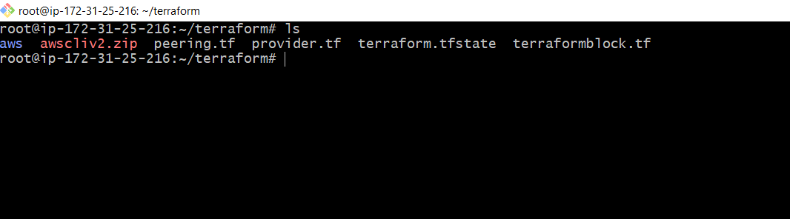

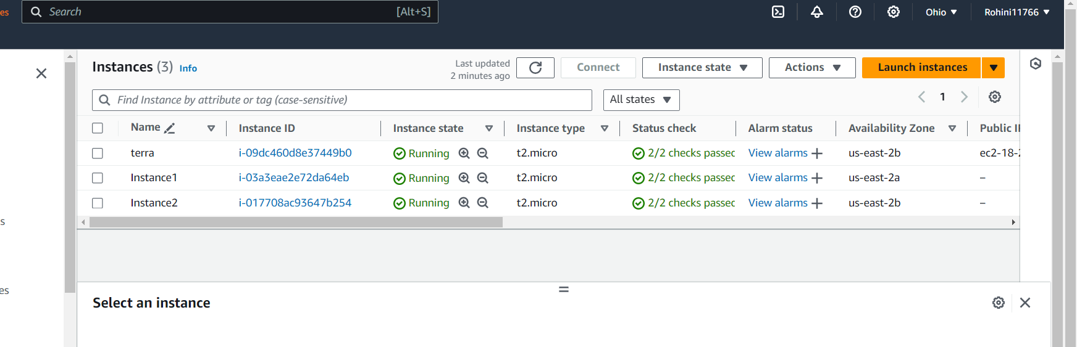

Terraform init

Terraform validate

Terraform apply

